**Mini project CS260**

**Team Members:**

**Akash Sinha -2101CS90**

**Aadit Sharma – 2101AI02**

**Ishani Sharma – 2101AI16**

A working TPC portal along with a fully detailed database containing the records of students, alumni, and companies with their placement details and specifics has been made using SQL, PHP, Javascript and CSS.

All the files we submitted have our names and student id at the start, along with a declaration of authorship.

A Brief Overview of the site and the related database tables will be hence shown in the following slides:

The index site for the portal is designed in the following way -

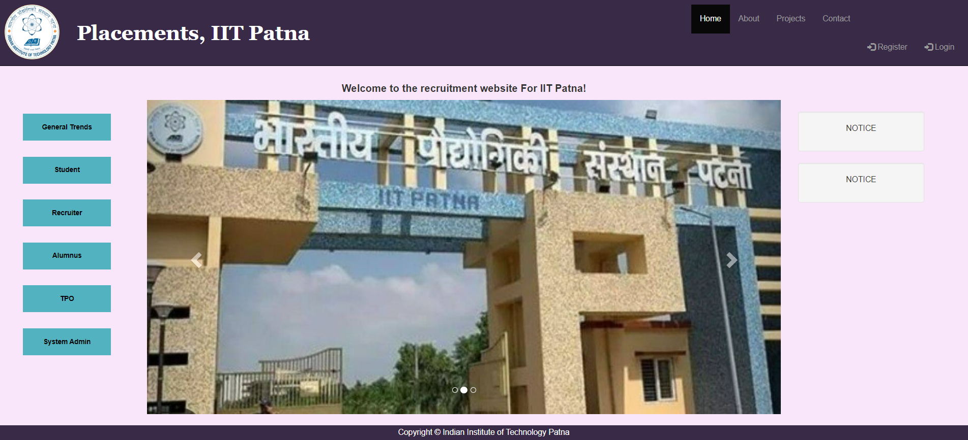

All the tasks have been divided into well-defined sub-groups:

1. **General Trends**

This webpage highlights the trends that have been followed in the past 4-5 years. A few of the notable trends would be the max salary offered, pie charts, and bar graphs delineating the division of placements company-wise and according to the area of technical field joined. Average and max packages provided by each company has also been shown.

The results from a particular year has been shown below –

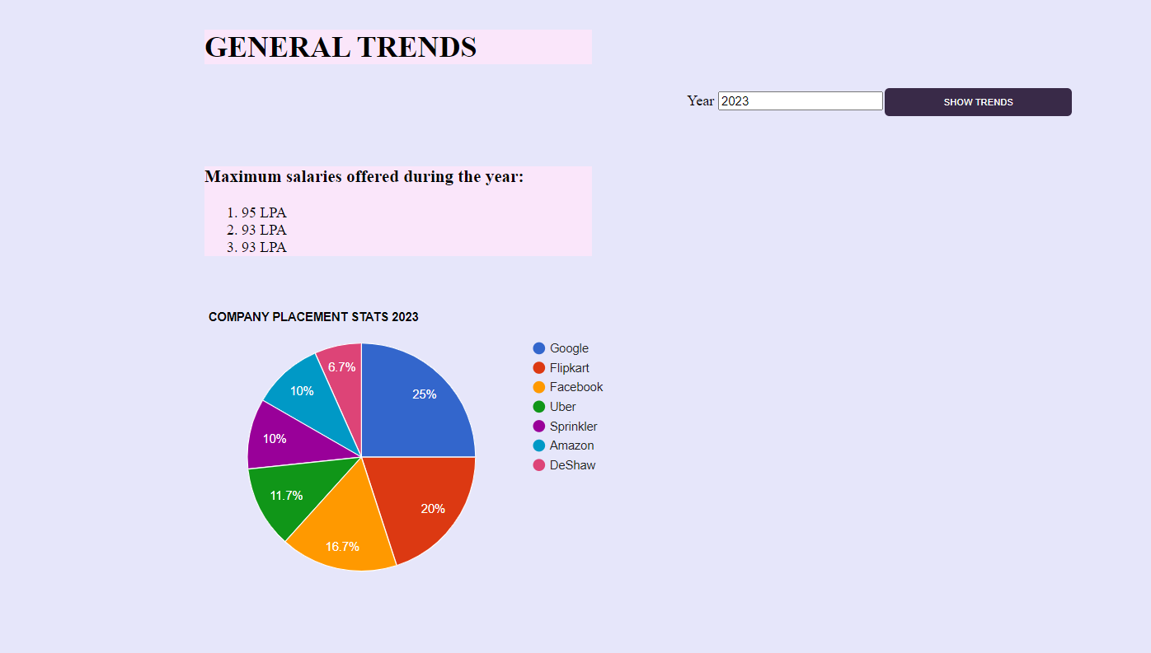

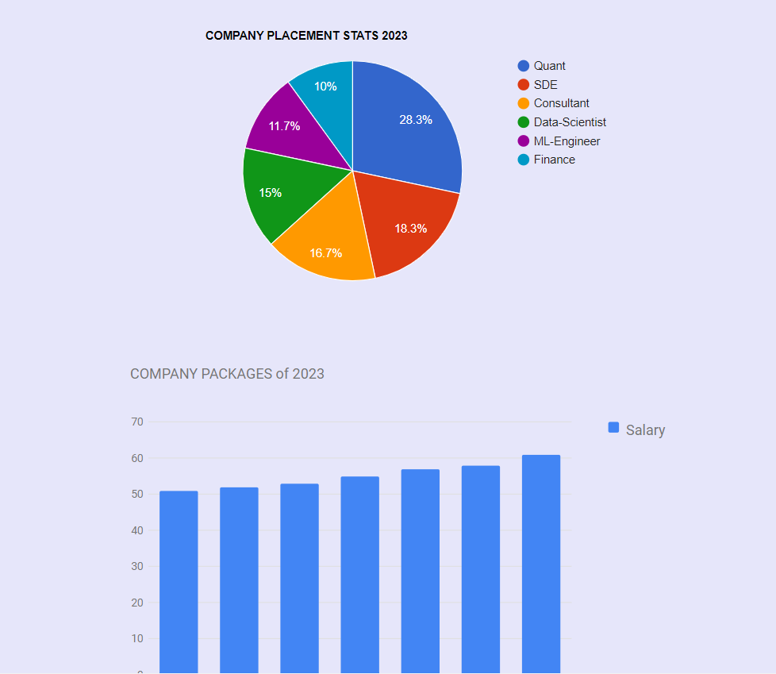

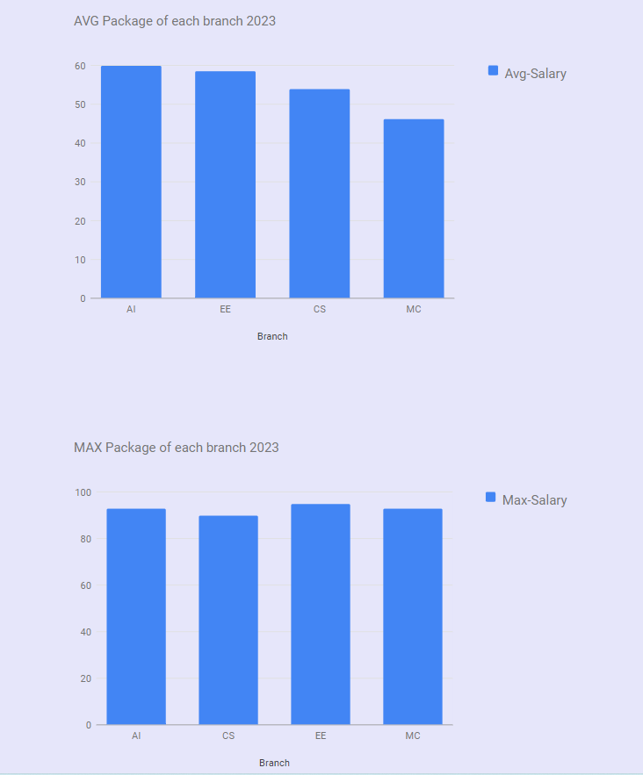

1. **Student**

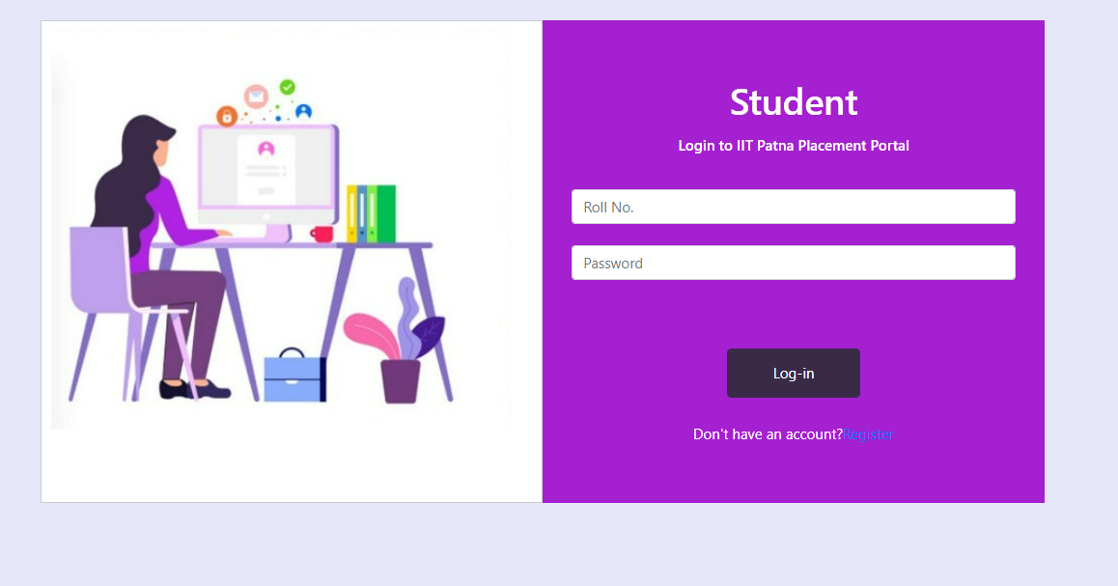

This webpage caters to all the queries a student may have regarding the placement season and eligibility in general. The login portal has been shown above.

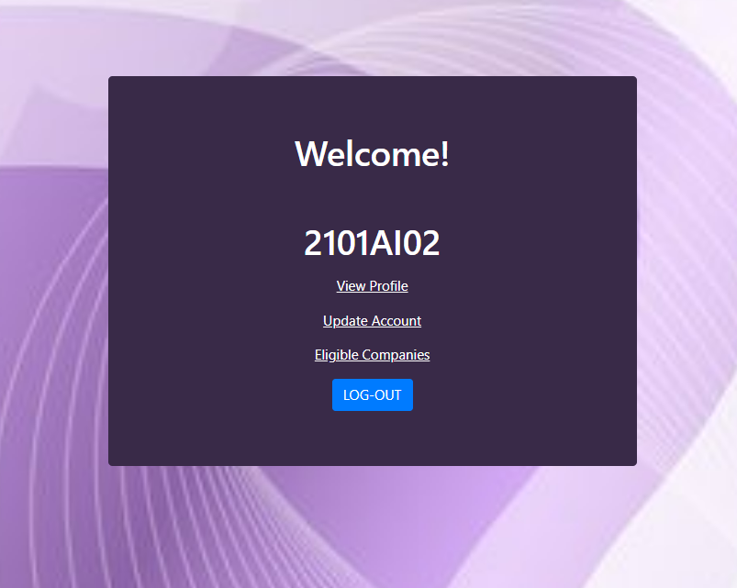

The buttons re-direct to the various functionalities implemented.

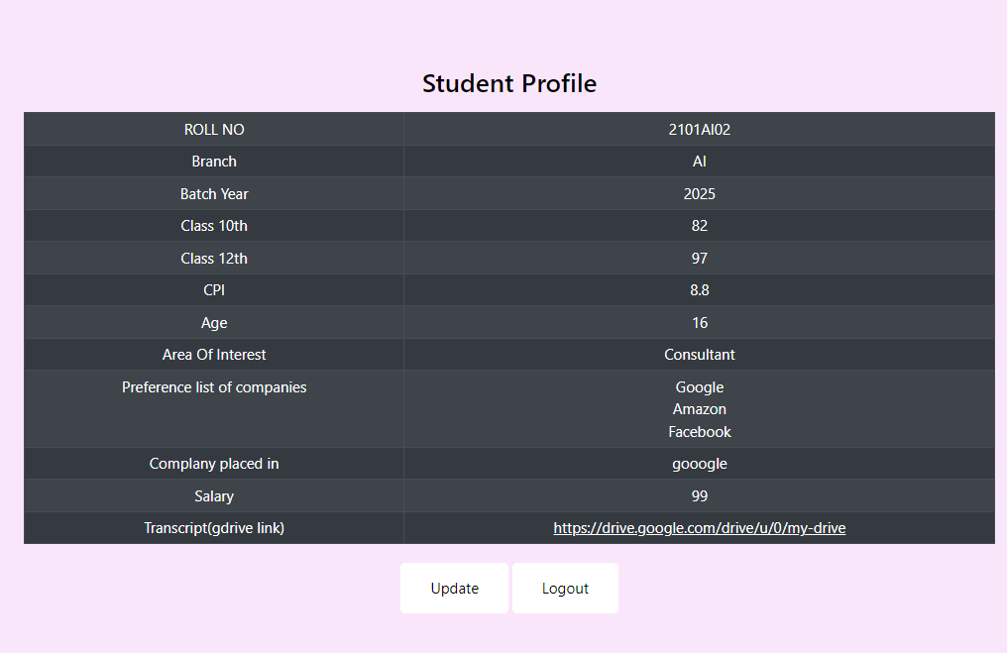

The profile of a student is shown above.

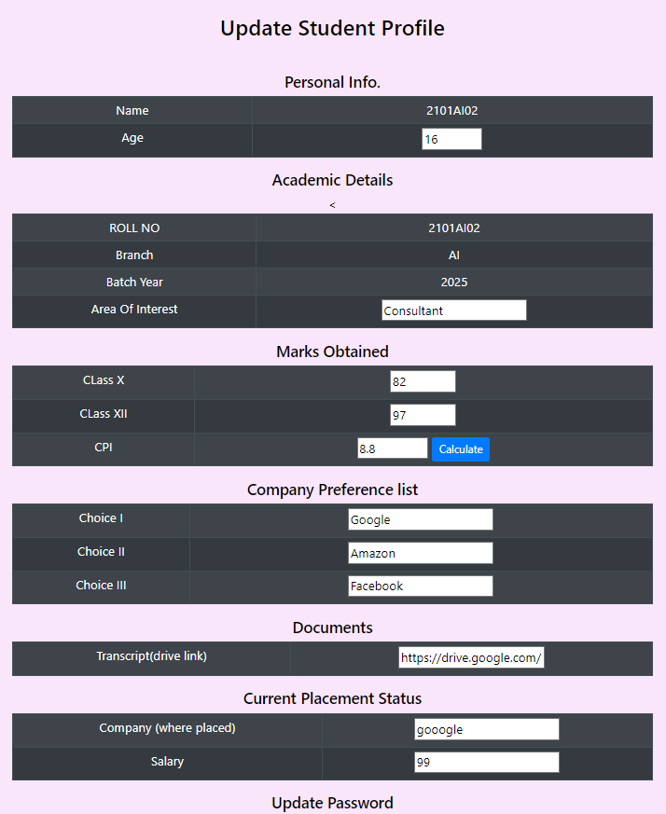

Update student portal is fully-customisable and directly changes the entries in the database.

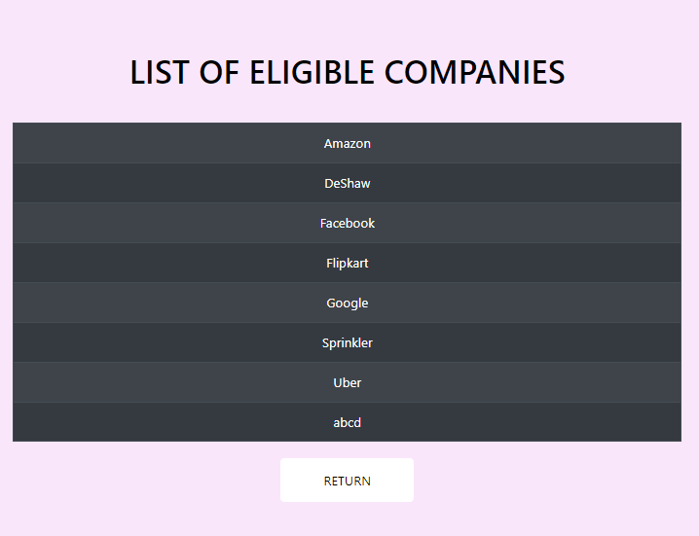

The following list shows the student, the list of companies he is eligible to apply for with his CPI during the remainder of the placement season.

1. **Recruiter/Company**

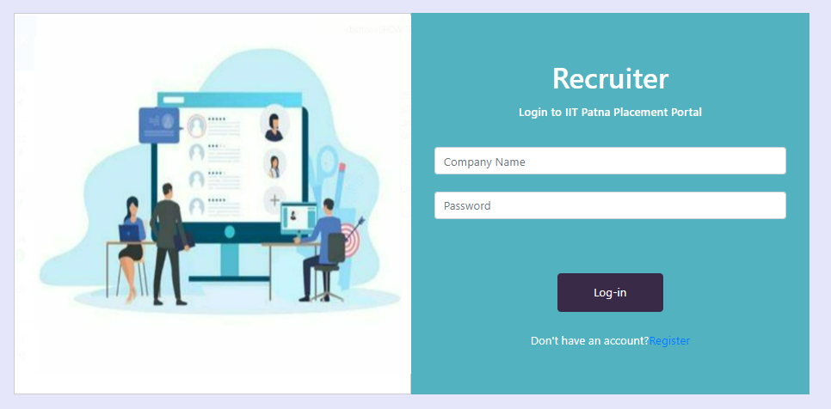

Login portal for the companies is shown above.

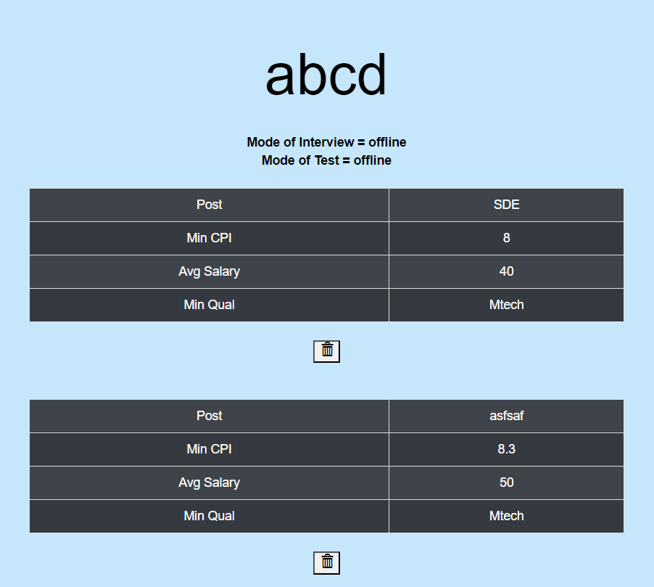

A list of posts offered by the company during the current placement season. The delete option is given in case an error is committed while filling in the new posts.

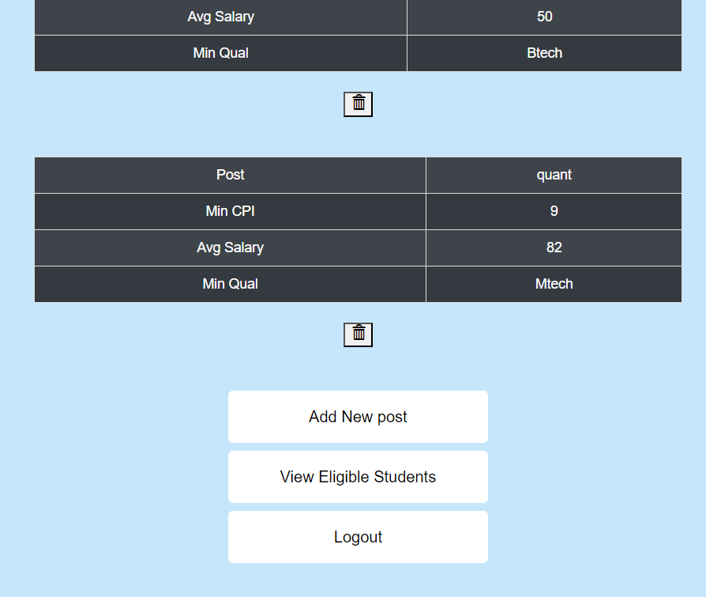

Provision added to add new post and view the list of eligible students who will be sitting for the placement season this year.

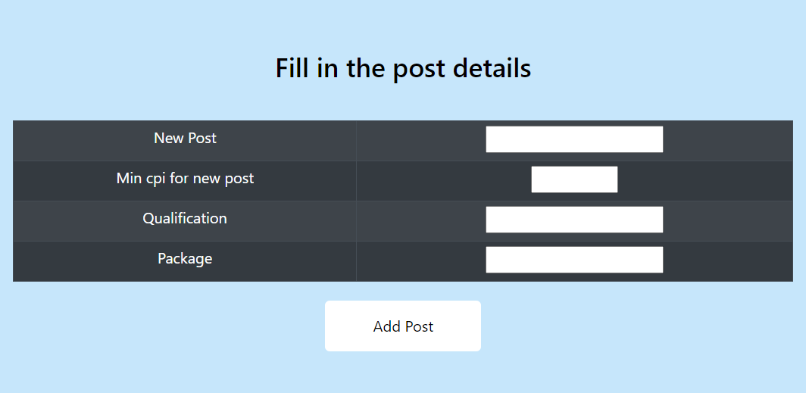

Portal used to add in new post according to the year by the company itself.

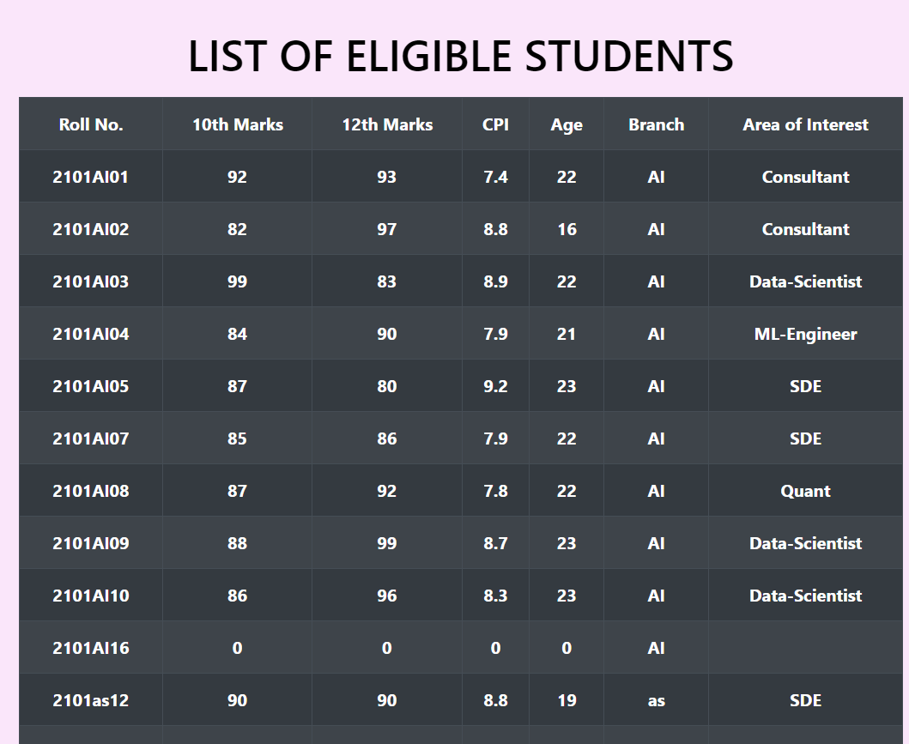

This is the list of students that the company will see showing all the valid entries who have minimum requirement for the CPI and have already not been placed in the company.

1. **Alumnus**

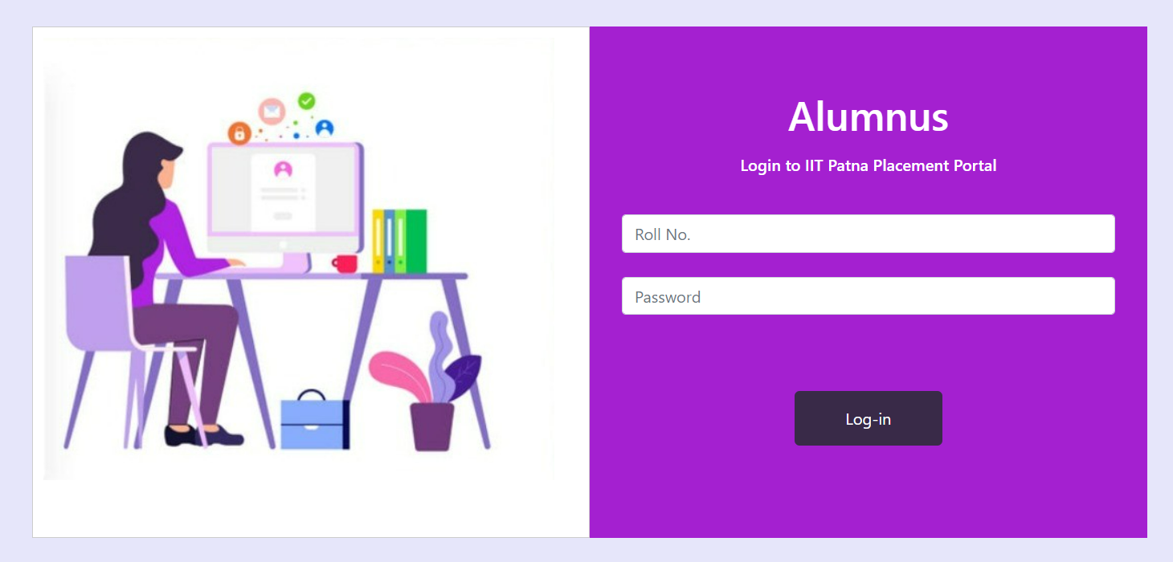

The login portal for the alumni of the institute is shown above. The login is taken using the unique roll number provided to every past student of the institution.

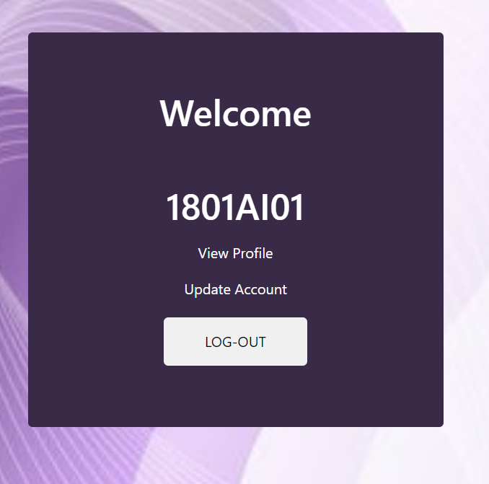

Profile to be seen by the alumni upon login

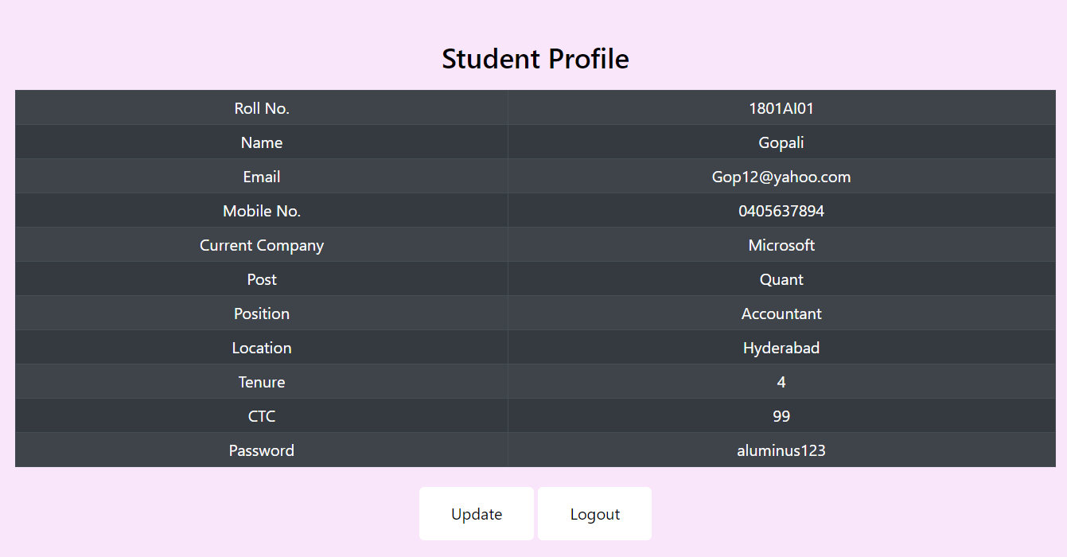

Details shown as gathered by the college throughout the 4 years. Can be edited by the alumni themselves and accepts NULL values as per the preference of the alumni.

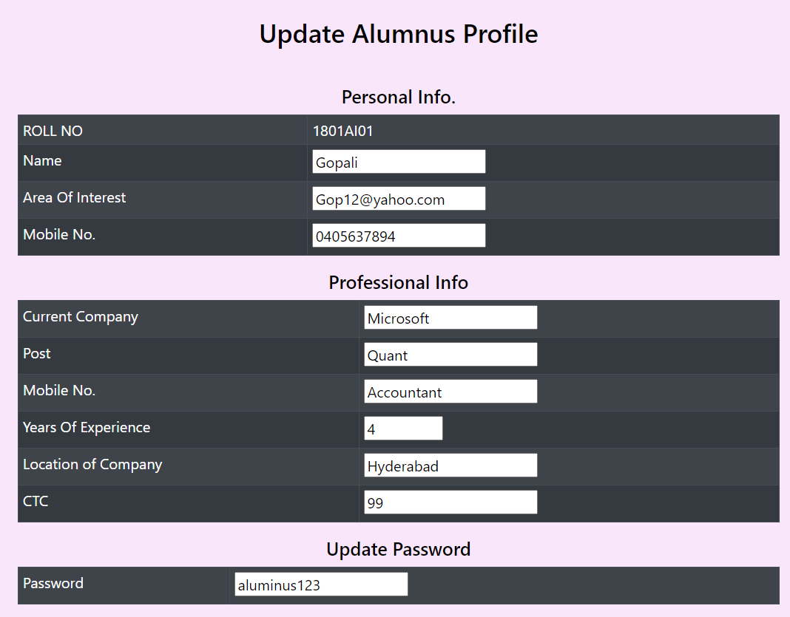

The update portal that can be accessed by the alumni.

1. **TPO (Training placement officer)**

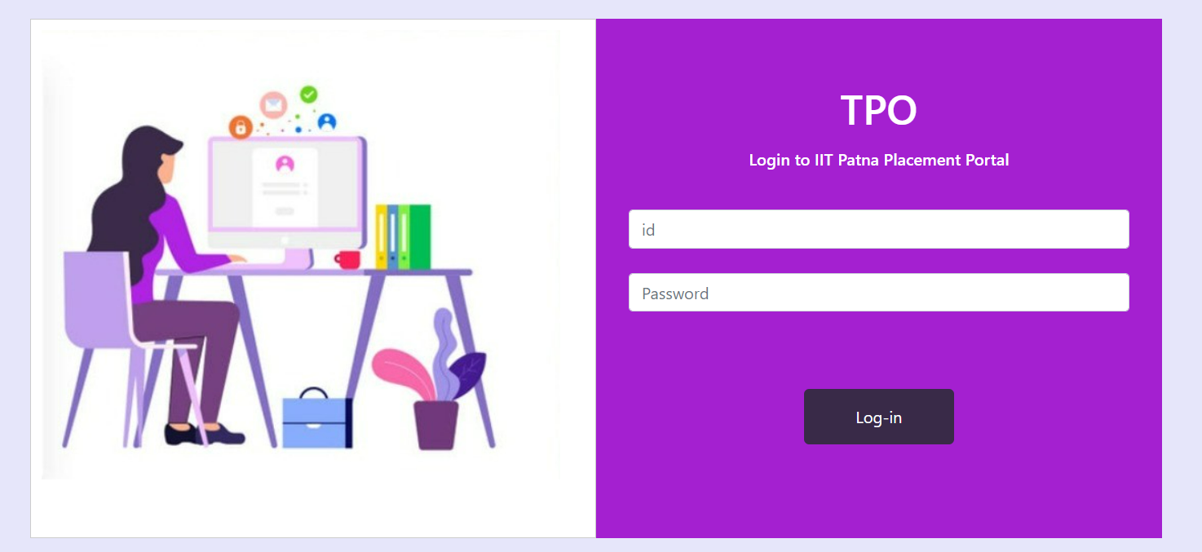

This is the portal for the login of the training placement officer, where he would have access to the whole database and can search for specific entries in the database without the use of sql.

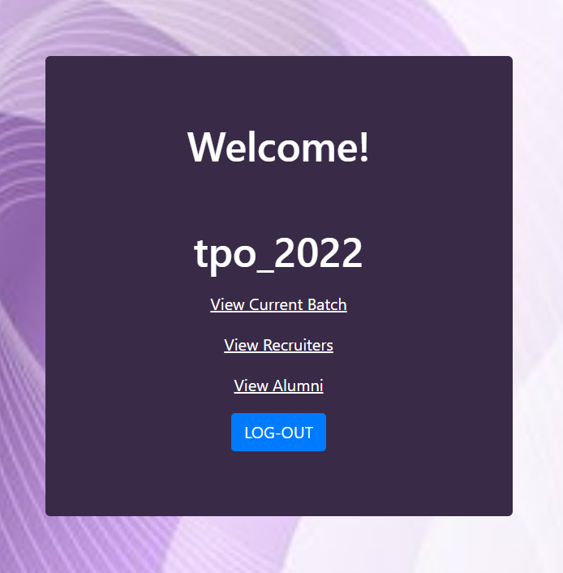

The portal as viewed by the officer.

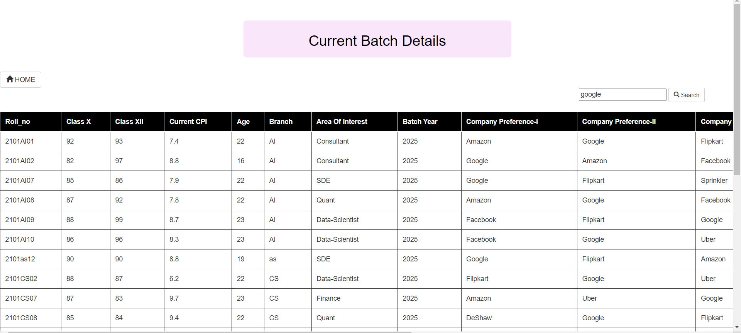

The search query works as a string match search. All datasets containing the given string in input are returned as output. In the above example the string “google” is matched and all the datasets containing “google” in all the tables of the database are returned. The query can be very specific according to the need of the TPO.

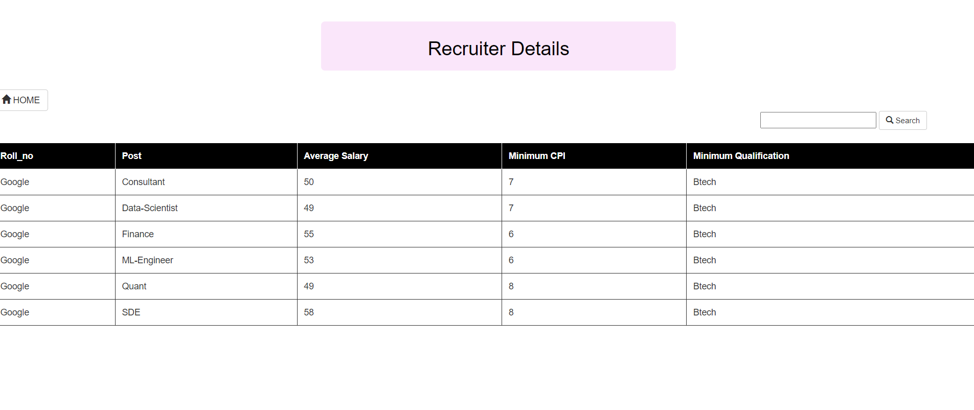

Upon reaching the recruiter details, TPO can gather information about a specific company or a specific post offered by the companies in the current placement season.

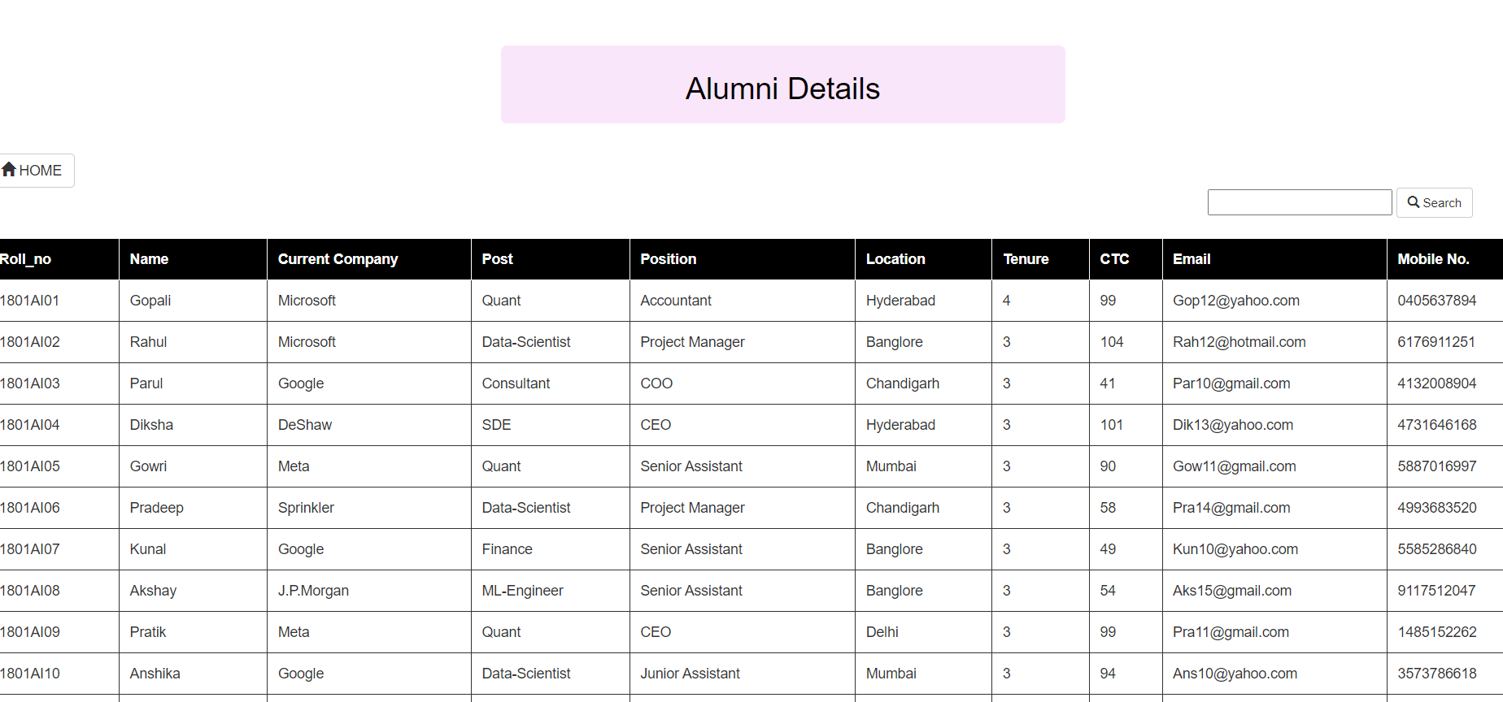

Similar to the above 2 interfaces, the alumni details can be accessed using the string match operator.

1. **System Admin**

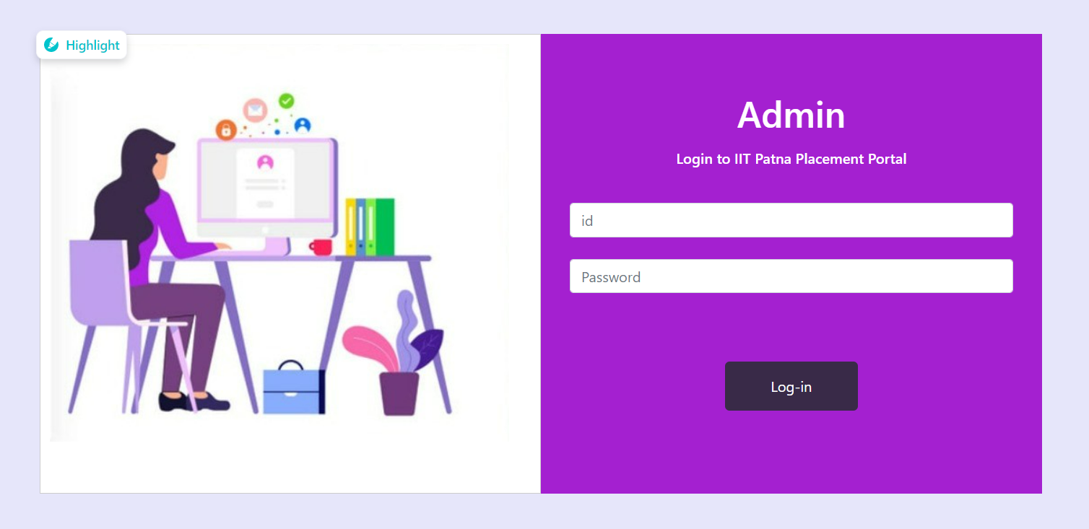

The Admin would view a portal in the following way.

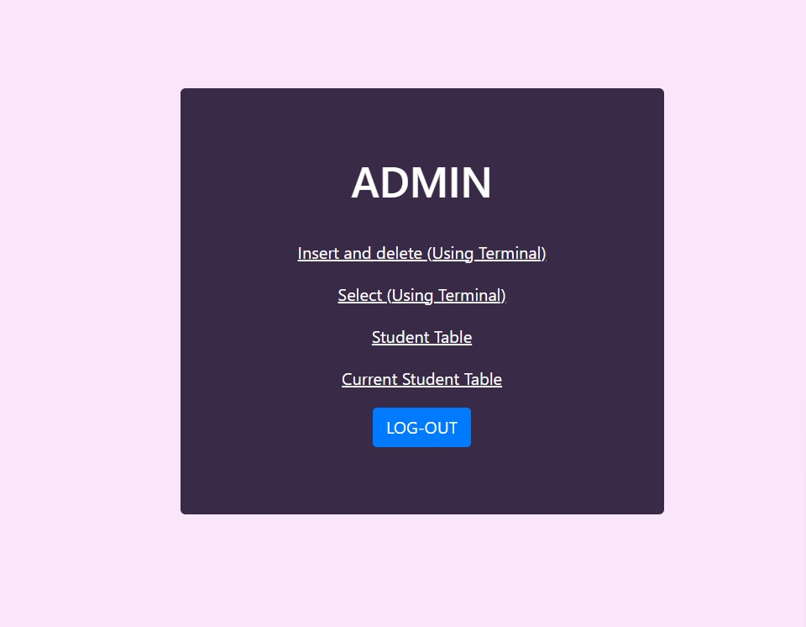

The following options are given to admin. The links only open upon authentication with the admin login and password.

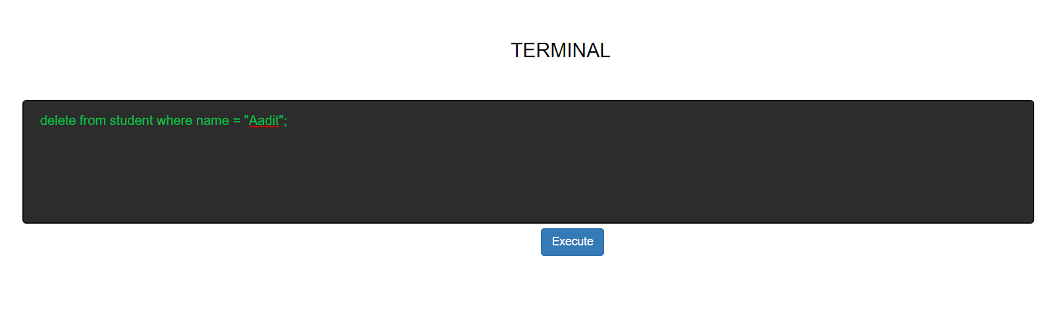

The first terminal gives options to insert and delete from any of the tables in the database.

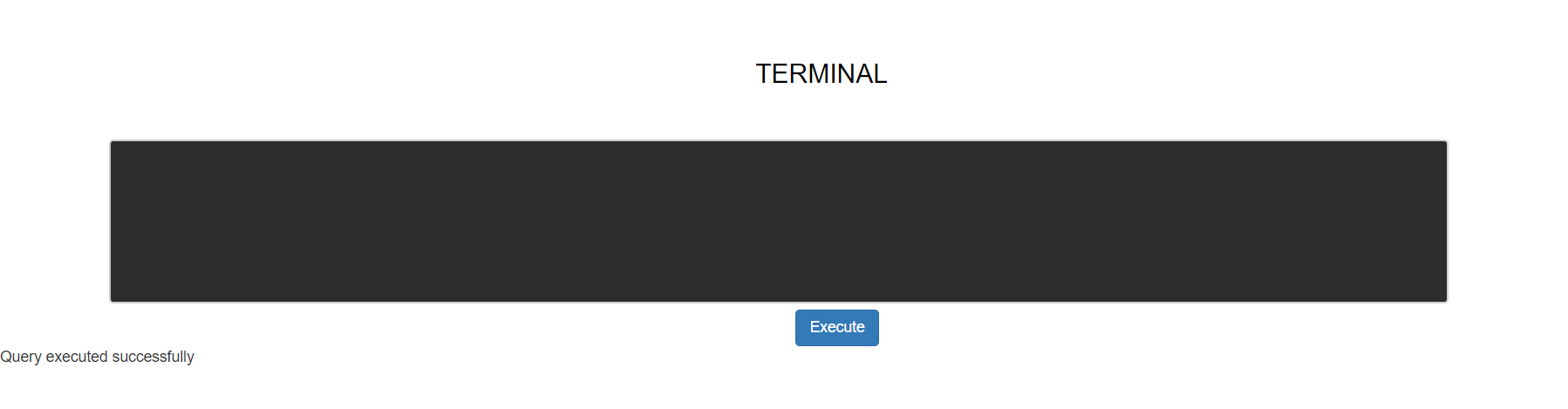

Query executed successfully in case of no errors.

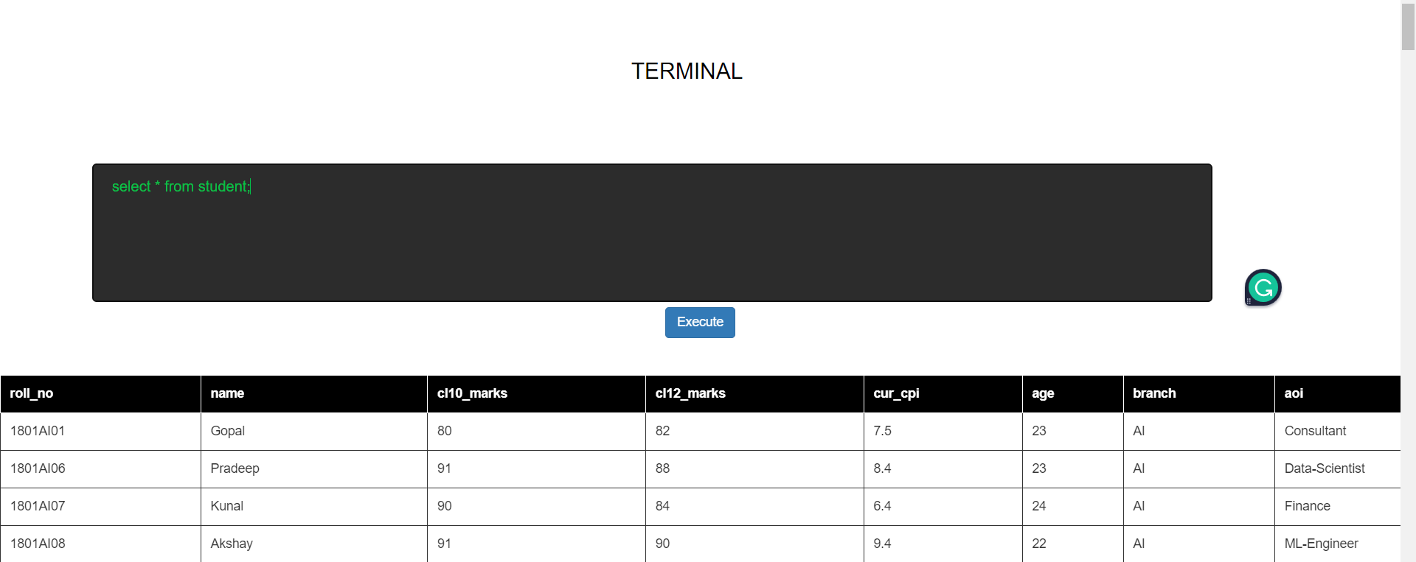

The second option where any select query can be viewed (an example is shown above).

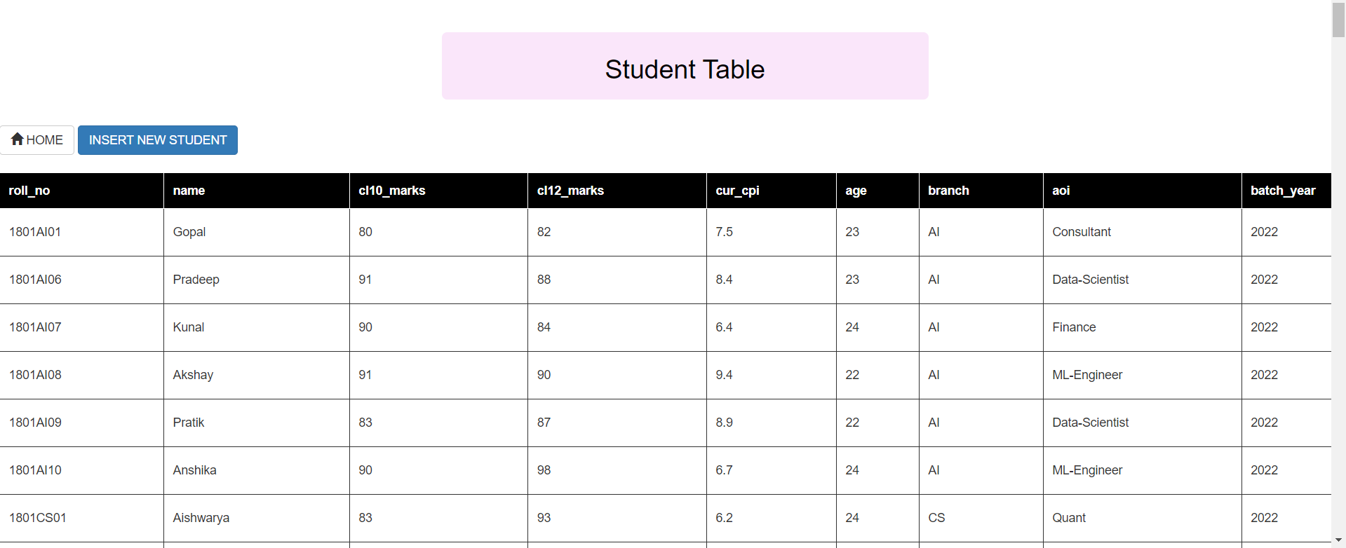

The student table showing the records of all the students currently studying in the institute.

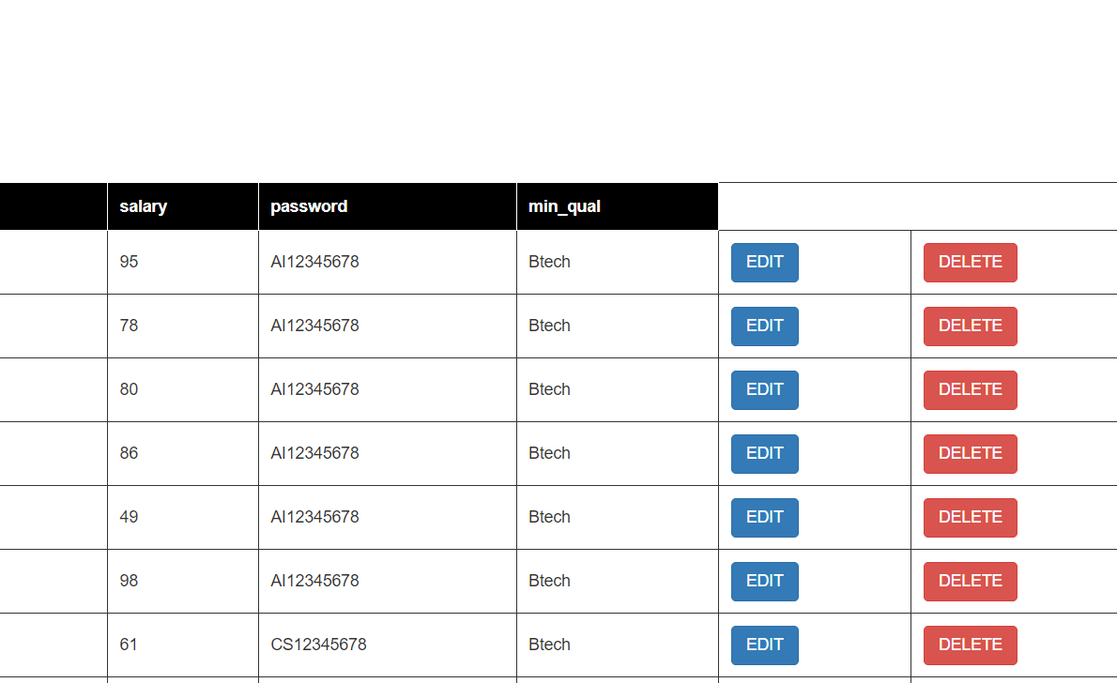

Option provided to edit and delete the records of each student.

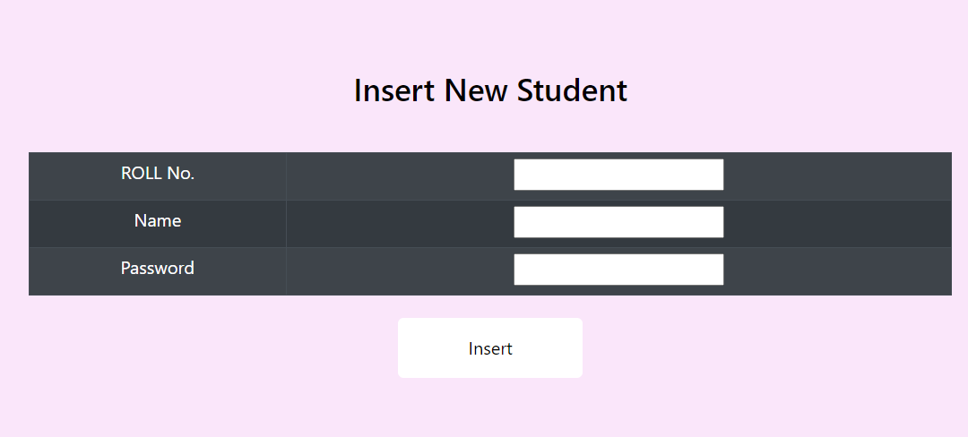

The interface to insert new student data in the database.

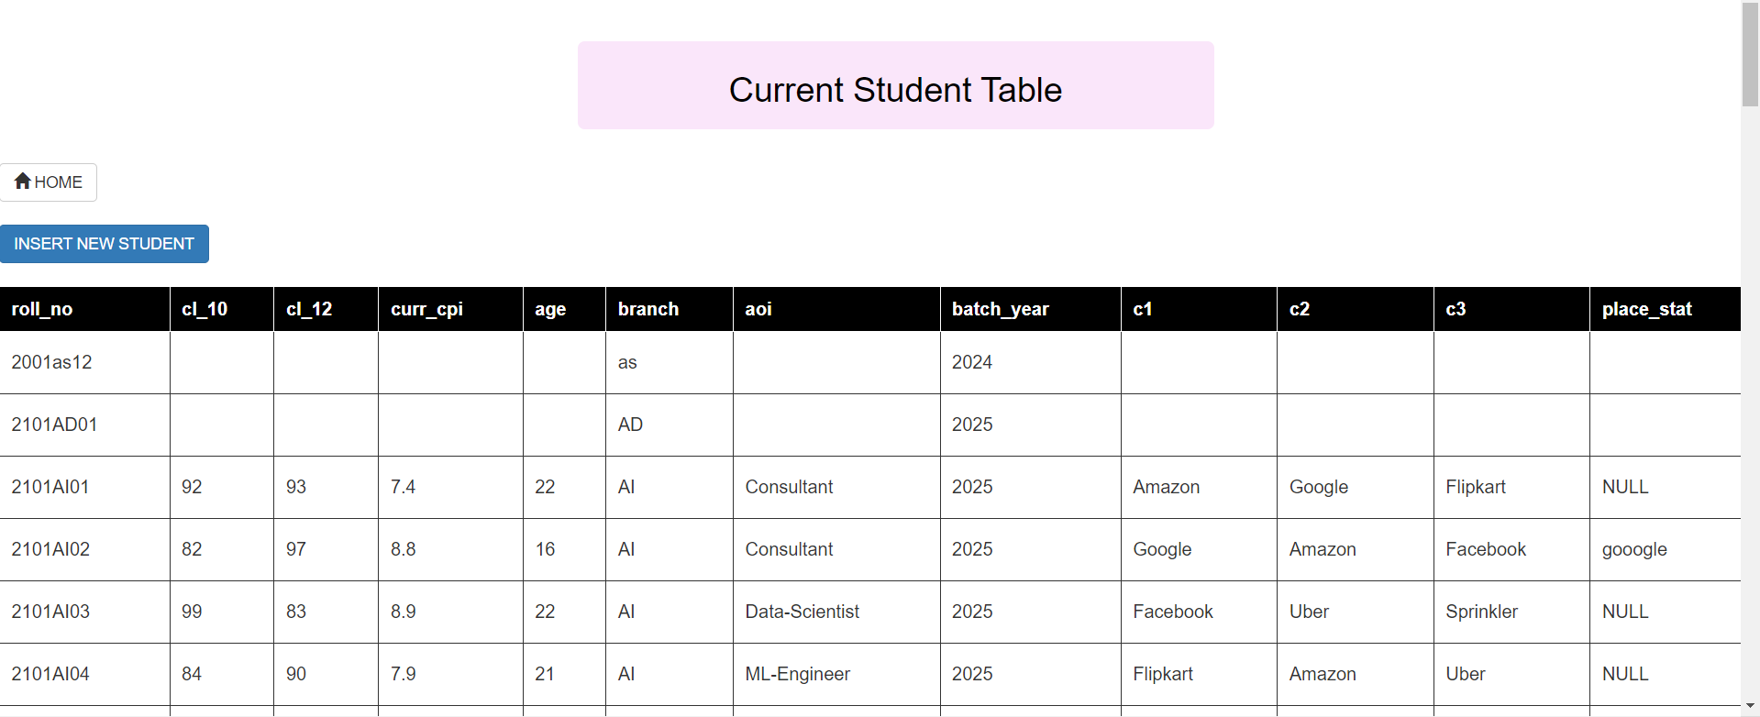A similar interface to operate on the values of the current student.

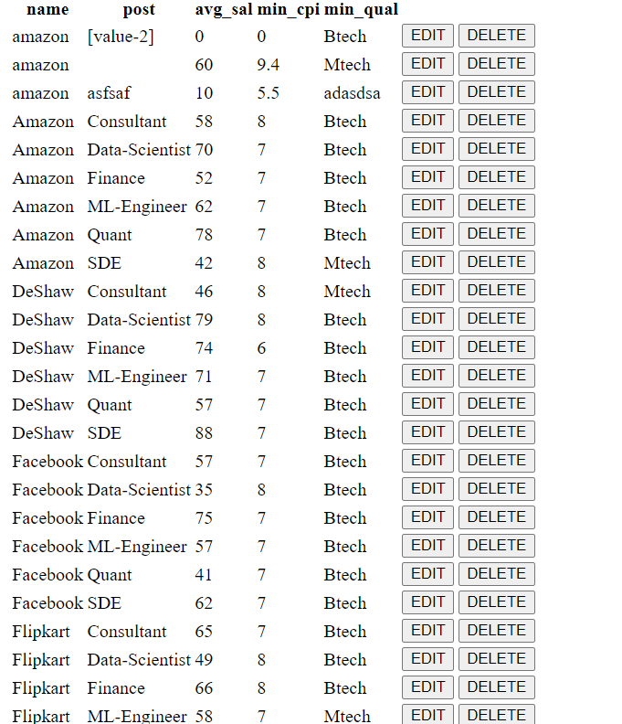   
  
Companies and post data similar to current student and student data. All the entries can be edited and deleted.

The data in Database is followed from the following ER model –

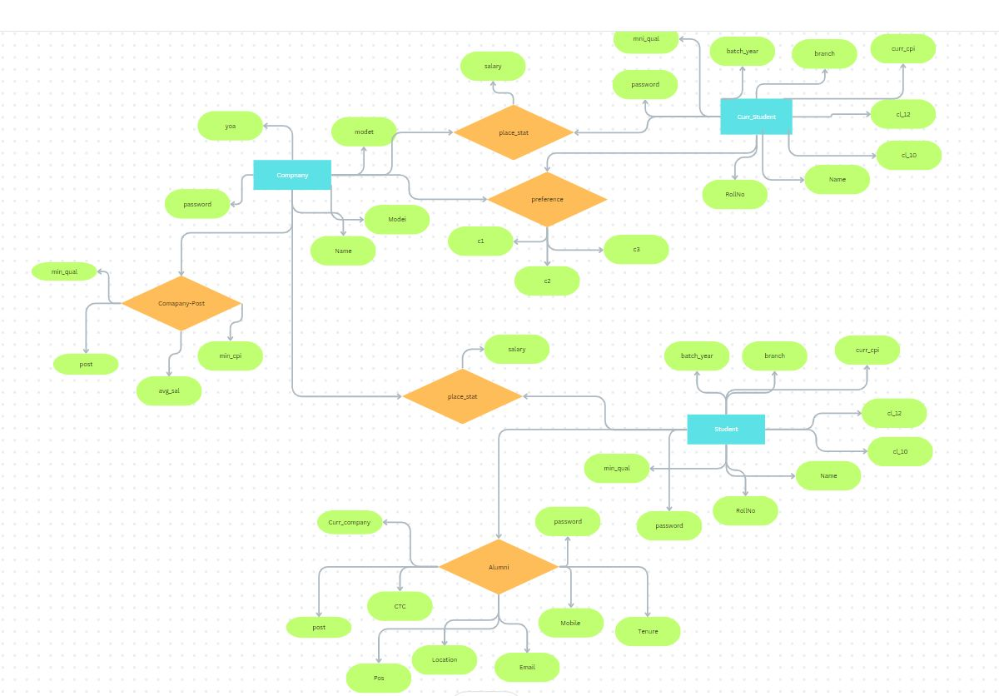

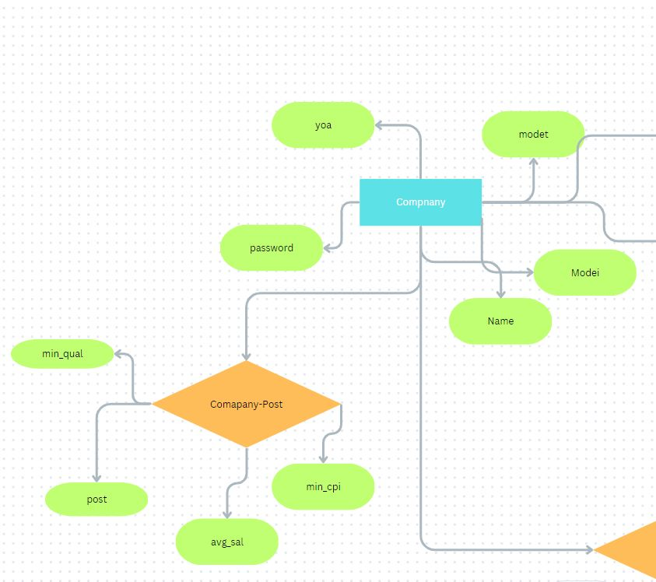

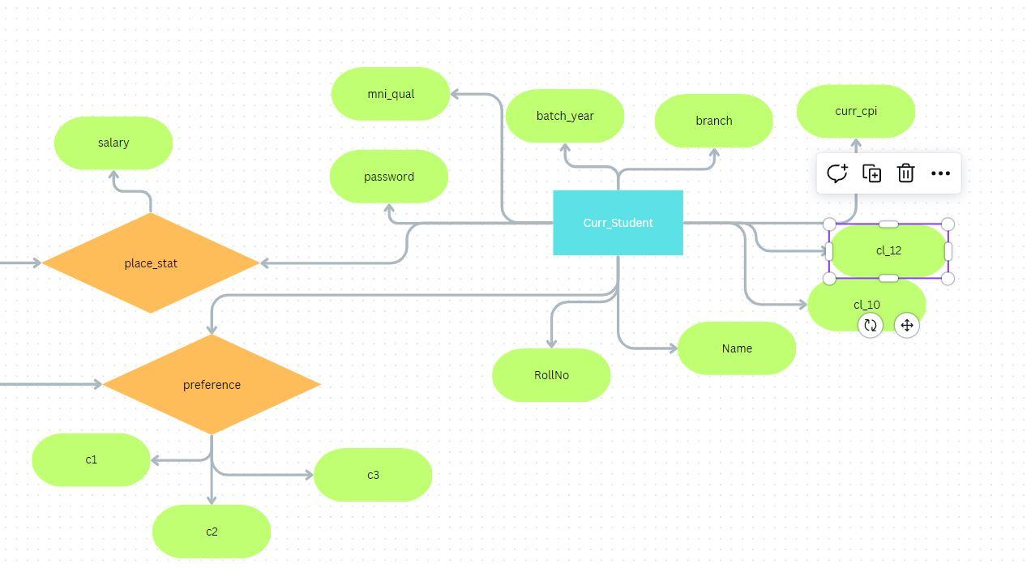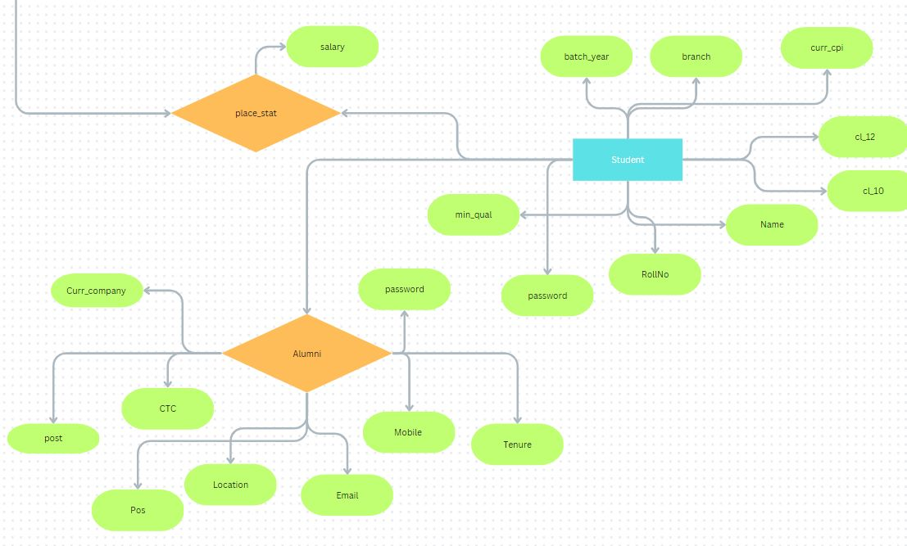

The relevant codes for the above website is uploaded in the following github link.

<https://github.com/Ishani-29/MiniProject_CS260>